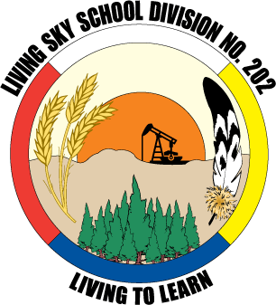
Grade 3
Carla Bernier & Alexis Christensen
Connaught School

First Nation’s Lifestyle Change Prior to and after the Signing of Treaty
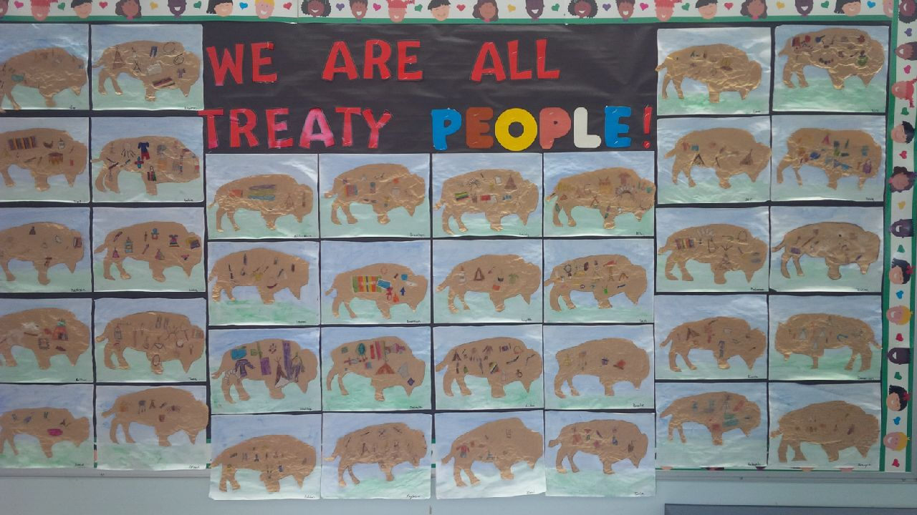
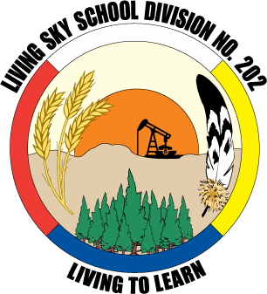
Desired Results
Stage One – What do we want them to learn?
Outcomes & Indicators:
Outcome: IN3.1
Analyze daily life in a diversity of communities.
- Describe characteristics of daily life in communities studied, and compare the ways in which the needs are met by individuals in diverse communities (e.g., housing, tools, work, use of the land, games, education).
- Give examples of how culture is reflected in daily life in various communities, and examine why these cultural elements are important (e.g., language, stories, cultural traditions, religious traditions, recreation, art, architecture, clothing).
Outcome: RW3.1
Appraise the ways communities meet their members’ needs and wants.
- Speculate upon various challenges faced by communities in meeting needs and wants, with evidence gathered from examining pictures, viewing media, and interpreting stories using a variety of fiction and non-fiction texts.
- Identify how individuals and communities meet needs and wants.
- Describe ways in which communities help ensure basic human needs are met (e.g., food and water, shelter, clothing, education, safety).
Outcome: CH3.1
Compare how arts expressions from various groups and communities may be a reflection of their unique environment (e.g., North and South Saskatchewan, urban and rural).
- Investigate many different kinds of arts expressions.
- Share information about an artist working in own community through individual research or collaborative inquiry.
d. Describe how an arts expression tells something about the community and culture in which it was created (e.g., heritage harvest dances).
Outcome: CH3.2
Demonstrate an awareness of traditional and evolving arts expressions of Saskatchewan First Nations and Métis artists in own communities or regions.

e. Observe, listen to, and inquire about First Nations and Métis arts and protocols related to arts expressions.

f. Investigate arts expressions of First Nations and Métis artists whose work speaks to the relationship between people, the land, and environment.

* Treaty Education Outcome: TR3.1 Examine the relationships between First Nations peoples and the land, before and after the signing of treaties.
Indicators: Describe the lifestyle changes of First Nations, prior to and after placement on reserves.

Big Ideas & Understandings: Essential Questions:
The Lifestyle of First Nations people has changed drastically prior to and after the signing of treaties.  First Nations people were nomadic people with a special relationship to the land. Everything they needed to survive was taken from the land, most importantly from the buffalo. | How has the lifestyle of First Nations people changed prior to and after the signing of treaties?  Why was the buffalo essential to First Nations lifestyle?

Knowledge: Do:
- First Nations people lived a nomadic lifestyle off the land before the signing of treaties and the arrival of the settlers.  - The buffalo was important to the survival of the Plains First Nations  - After the arrival of the settlers and the signing off treaty, First Nations lifestyle changed drastically. | - Identify what a nomadic lifestyle is and how First Nations people lived off the land.  - View images of the lifestyle of First Nations people before the signing of treaty.  - Discuss the importance of the buffalo.  - Illustrate all of the uses of the buffalo.  - Read and respond to text about First Nations lifestyle prior to and after treaty signing.  - Generate interview questions  - Pose questions to a First Nation guest

EVIDENCE OF UNDERSTANDING
Stage Two – How will we determine what they know?

Assessment:
Summative  Performance Task  Visualization and Description  Buffalo Representation  Two-Pane Visualization | Formative  Pre-Assessment  T-Chart  On-going assessments of process  Class discussion  Anchor Chart  Interview questions  Exit Slip

LEARNING PLAN
Stage Three – How will we teach?

Lesson 1- What was the First Nation’s lifestyle like prior to treaty signing?
Using an anchor chart introduce the essential question, How has the lifestyle of First Nations people changed prior to and after the signing of treaties? Let students know that we will come back to our anchor chart daily to add information as the unit progresses.
Discuss the prior knowledge of students using a t-chart labeled First Nations lifestyle before and after the signing of treaty.

Lesson 2- How is First Nations lifestyle represented in art?

Read the book Hidden Buffalo by Rudy Weibe. Ask students to pay close attention to the Michael Lonechild paintings represented in the book. Discuss the different aspects of lifestyle presented. How did First Nations people meet their needs? How did the nomadic lifestyle meet First Nation’s needs? Add any new findings to the t-chart from lesson 1.

Lesson 3- Visualizing First Nation’s Lifestyle Prior to treaty signing?

Review through discussion First Nations lifestyle prior to the arrival of the newcomers (living off the land, hunting, gathering, Elders as the teachers, no waste, tipi’s, communal living, every day was work to survive). Students will illustrate a visualization depicting First Nations lifestyle. Ask them to write a short description below their illustration. Afterwards, students can share with a partner or the class what they have done.

Lesson 4- What would it be like today to live like First Nations people used to prior to the signing of Treaty?

Watch APTN’s series (can be found on their website) called Back in the Day. The show is a reality TV show that follows a group of five youth as they embark on a journey of life away from the city to the bush, living off the land like their ancestors did. Ask students to discuss how the youth did in a small group and then respond in writing to the following question, How did the youth do away from city life? Do you think they could survive without help? Would you be able too? Allow time for students to share in pairs or small groups.

Lesson 5- Why was the buffalo essential to First Nations lifestyle?

Read Depending on the Buffalo pp. 12-13 from the book Nations of the Plains by Bobbie Kalman. Discuss the importance of the buffalo with students. Share with students the illustration What you can make with Bison? pp. 22-23 from the book Native Americans A Visual Exploration by S.N Paleja. Students can work with a partner or in a small group to investigate all of the different ways the buffalo was used by First Nations people. Exit Slip: Why did the First Nations people live a nomadic lifestyle?

Lesson 6- What were some of the uses of the buffalo by First Nations people?

Students will create a representation of the buffalo and its many uses. Students will start by painting a landscape on paper. Then, using a cutout of a buffalo they can trace the shape on a piece of a brown paper bag. Students will then crumple the buffalo shape and glue it on their landscape. Students can draw as many uses of the buffalo that they can inside the buffalo then color the illustrations to complete.

Lesson 7- How did First Nations lifestyle begin to change?

Read End of a Way of Life pp. 28-29 in the book Nations of the Plains by Bobbie Kolman. Discuss the end of the First Nations people’s way of life and the beginning of a new one. What were some of the changes? What were some of the reasons for the change? How easy or hard would that have been? Ask students to fill in the other side of the t-chart.

Lesson 8- How did First Nations lifestyle change from past to present?

Compare images of lifestyle before treaty and after. View works of art from First Nations artists Henry Beaudry, Micheal Lonechild, and Allen Sapp, Ask students whether each picture represents life prior to or after the signing of treaty. Have students illustrate a picture using a 2 pane visualization chart of the lifestyle changes from the past to the present based on the First Nations artists work.

Lesson 9- First Nations Lifestyle on Reserve Today

Invite a First Nation guest to share what life is like on a reserve today. Please refer to http://treaty6education.lskysd.ca/seekingknowledge for First Nation’s protocol. As a class, generate a list of interview questions to pose to the guest. Afterwards, lead a discussion comparing life on and off reserve.

Buffalo Representation

